


AI-BASED FACE RECOGNITION ATTENDANCE MANAGEMENT SYSTEM

AN INTERNSHIP REPORT

Submitted by

TEJASHWINI BV – 20231CSE3046

Under the guidance of,
Mr. Sakthi S

BACHELOR OF TECHNOLOGY

IN

COMPUTER SCIENCE AND ENGINEERING


PRESIDENCY UNIVERSITY
BENGALURU
APRIL 2026



PRESIDENCY SCHOOL OF COMPUTER SCIENCE AND ENGINEERING
BONAFIDE CERTIFICATE

Certified that this report “AI-Based Face Recognition Attendance Management System” is a bonafide work of TEJASHWINI BV (20231CSE3046), who has successfully carried out the internship work and submitted the report for partial fulfilment of the requirements for the award of the degree of BACHELOR OF TECHNOLOGY in COMPUTER SCIENCE AND ENGINEERING during 2025-2026.

Mr. Sakthi S  Project Guide  PSCS  Presidency University | Dr. R. Balakrihnan  Program Internship Coordinator  PSCS  Presidency University | Dr. Md Ziaur Rahaman  School Internship Coordinator  PSCS  Presidency University

Dr. Asif Mohammed H B  Head of the Department,  PSCS  Presidency University | Dr. Duraipandian N  Dean  PSCS / PSIS  Presidency University

Name and Signature of the Examiners
Sl. No | Name | Signature | Date

1

2

PRESIDENCY UNIVERSITY

PRESIDENCY SCHOOL OF COMPUTER SCIENCE AND ENGINEERING
DECLARATION

I am a student of final year B.Tech in COMPUTER SCIENCE AND ENGINEERING at Presidency University, Bengaluru, named TEJASHWINI BV, hereby declare that the internship work titled “AI-Based Face Recognition Attendance Management System” has been independently carried out by me and submitted in partial fulfillment for the award of the degree of B.Tech in COMPUTER SCIENCE and ENGINEERING during the academic year of 2025-2026. Further, the matter embodied in the internship has not been submitted previously by anybody for the award of any Degree or Diploma to any other institution.

TEJASHWINI BV USN: 20231CSE3046 Signature

PLACE: BENGALURU
DATE: 24 April 2026
INTERNSHIP COMPLETION CERTIFICATE


ACKNOWLEDGEMENT

For completing this internship work, I have received the support and the guidance from many people whom I would like to mention with deep sense of gratitude and indebtedness. I extend my gratitude to our beloved Chancellor, Pro-Vice Chancellor, and Registrar for their support and encouragement in completion of the internship.
I would like to sincerely thank my internal guide Mr. Sakthi S, Assistant Professor, Presidency School of Computer Science and Engineering, Presidency University, for his moral support, motivation, timely guidance and encouragement provided to me during the period of internship work.
I am also thankful to Dr. Asif Mohammed HB, Professor, Head of the Department, Presidency School of Computer Science and Engineering Presidency University, for his mentorship and encouragement.
I express my cordial thanks to Dr. Duraipandian N, Dean PSCS & PSIS and the Management of Presidency University for providing the required facilities and intellectually stimulating environment that aided in the completion of my internship work.
I am grateful to Dr. Md Ziaur Rahaman, Internship Coordinator and Dr. R. Balakrishnan, Mr. Sakthi S, Program Internship Coordinator, Presidency School of Computer Science and Engineering, or facilitating problem statements, coordinating reviews, monitoring progress, and providing their valuable support and guidance.
I am also grateful to Teaching and Non-Teaching staff of Presidency School of Computer Science and Engineering and also staff from other departments who have extended their valuable help and cooperation.

TEJASHWINI BV

ABSTRACT

The internship experience at the Rail Wheel Factory revolves around solving the drawbacks that come with conventional methods of attendance recording in a highly automated manufacturing setting. With the growing trend of industrial firms undergoing digital transformation, there is a need for companies to adopt more effective ways of managing their workforce. An internship was carried out with the main objective of coming up with an effective method of managing attendance for the factory by developing an intelligent system of recording attendance.

In this internship, the idea behind the solution revolves around developing an "AI-based Face Recognition Attendance Management System." In this solution, full-stack web development was utilized to develop both the front-end part and back-end functionalities of the application. For instance, the front-end part was designed to offer an easy to use user interface. The back-end architecture was built to support data handling activities such as validation and storage of attendance information. The system uses machine learning and AI technologies to detect the faces of individuals and match them to those stored in a database.

This system has proven to be highly accurate in identifying employees, with consistent performance under diverse environmental settings. The shift from manual registers to this automated system has played a key role in decreasing administrative workload and minimizing errors while providing instant reports for human resources management. This internship has been able to showcase the use of full-stack development and artificial intelligence in addressing real-life industrial workflow problems.

TABLE OF CONTENTS

Sl. No. | Title | Page No.
 | Declaration | iii
 | Acknowledgement | v
 | Abstract | vi
 | List of Figures | ix
 | List of Tables | x
 | Abbreviations | xi
1. | Introduction  1.1 Background  1.2 Statistics of Internship  1.3 Prior existing technologies  1.4 Proposed approach  1.5 Objectives  1.6 SDGs  1.7 Overview of internship report | 1  1  2  2  3  3  4
2. | Literature Review | 6
3. | Methodology  3.1 Research Design  3.2 Data Collection  3.3 Verification and Validation | 9  10  10
4. | Project Management  4.1 Internship timeline  4.2 Risk analysis  4.3 Internship budget | 12  15  16
5. | Analysis and Design  5.1 Requirements  5.2 Block Diagram  5.3 System Flow Chart  5.4 Choosing devices  5.5 Designing units  5.6 Standards  5.7 Mapping with IoTWF reference model layers  5.8 Domain model specification  5.9 Communication model  5.10 IoT deployment level  5.11 Functional view  5.12 Mapping IoT deployment level with functional view  5.13 Operational view  5.14 Other Design | 17  21  22  23  24  27  27  28  29  29  29  31  32  32
6. | Hardware, Software and Simulation  6.1 Hardware  6.2 Software development tools  6.3 Software code  6.4 Simulation | 34  35  36  38
7. | Evaluation and Results  7.1 Test points  7.2 Test plan  7.3 Test result  7.4 Insights | 40  41  41  44
8. | Social, Legal, Ethical, Sustainability and Safety Aspects  8.1 Social aspects  8.2 Legal aspects  8.3 Ethical aspects  8.4 Sustainability aspects  8.5 Safety aspects | 45  45  46  46  46
9. | Conclusion  9.1 Conclusion  9.2 Future Enhancements | 48  49
 | References | 50
 | Base Paper | 52
 | Appendix | 55

LIST OF FIGURES
Sl. No. | Figure Name | Caption | Page No.
1 | Figure 1.1 | Sustainable development goals | 4
2 | Figure 5.1 | Functional Block Diagram | 21
3 | Figure 5.2 | System flow chart | 22
4 | Figure 5.3 | Functional view for job employment | 30
5 | Figure 5.4 | Mapping IoT deployment level with functional view | 31
6 | Figure 6.1 | Backend software code | 36
7 | Figure 6.2 | Frontend Software Code | 37
6 | Figure 6.3 | Auth.js simulation | 38

LIST OF TABLES

Sl. No. | Table Name | Table Caption | Page No.
1 | Table 5.1

LIST OF TABLES

Sl. No. | Table Name | Table Caption | Page No.
1 | Table 4.1 | Internship planning timeline | 12
2 | Table 4.2 | Internship implementation timeline | 14
3 | Table 5.1 | Summarizing requirements | 20
4 | Table 5.5 | Description of Domain model | 29

ABBREVIATIONS

Abbreviation | Full Form
AI | Artificial Intelligence
CV | Computer Vision
API | Application Programming Interface
PKL | Pickle File Format
DL | Deep Learning
SQL | Structured Query Language
SQLite | Structured Query Language Lite
CNN | Convolutional Neural Network
GUI | Graphical User Interface
CPU | Central Processing Unit
TTS | Text to Speech
TS | Timestamp
OS | Operating System

Chapter 1

INTRODUCTION

AI-Based Face Recognition Attendance Management System
An AI-Based Face Recognition Attendance Management System is an automated attendance management system that uses face recognition technology for identifying people and marking their attendance without any physical contact or human intervention. The conventional attendance management systems, like maintaining attendance registers, ID cards, or biometric fingerprint-based systems, require physical contact between two individuals, time consumption, and sometimes even proxy attendance. However, face recognition-based attendance is faster, contact-free, and more secure.
The face recognition-based attendance management system works on the principle of acquiring images or video feed from a camera, identifying faces, and then matching them with a pre- stored database of people. By employing advanced computer vision techniques, face recognition systems can recognize individuals based on unique features like the distance between two eyes, nose shape, face structure, etc., and mark their attendance automatically upon identification.

Background
Attendance management is an important task in organizations, educational institutions, and working environments. Traditionally, attendance records are maintained manually using registers, sign-in sheets, and ID cards. However, such traditional methods are often found to be time-consuming and prone to human error and fraudulent practices such as proxy attendance.
Due to the recent advancements in Artificial Intelligence (AI) and Computer Vision, automated attendance management has gained popularity for efficient and accurate performance of tasks. Face Recognition is a subfield of AI and image processing that allows computers to recognize and identify faces based on facial characteristics. By recognizing the unique patterns of faces, AI can accurately recognize and identify faces even at different illumination conditions.

Statistics
The AI-Based Face Recognition Attendance Management System utilizes the Base
Presidency School of Computer Science and Engineering, Presidency University

advanced computer algorithms based on Artificial Intelligence and Computer Vision the automating the attendance recording process. Research suggests that traditional manual attendance systems require around 5-10 minutes per class, while face recognition attendance systems can record attendance in less than 30 seconds. This increases efficiency by around 80-90%. Statistical analysis of the attendance management system indicates that it improves accuracy, speed, and efficiency in attendance management compared to traditional attendance management practices.

Prior existing technologies
Prior to the advent of AI face recognition technology, organizations and institutions of learning employed various traditional methods of recording attendance. Among these was the traditional manual attendance register, which involved calling out students' names. Although simple, this method was cumbersome and often involved various human error issues, including proxy attendance.
Traditionally, before the advent of AI-based face recognition-based attendance management systems, various traditional methods of employee/student attendance tracking have been in use.

Proposed approach
The proposed system utilizes the latest technologies in Artificial Intelligence and Computer Vision domains to provide efficient and automated attendance management using facial recognition technology. Images of the individuals are taken using a camera installed at the entrance of a classroom or a workplace. The images are then processed in real time using a face detection algorithm to detect and extract facial features from the images.
The AI face recognition system aims at automating the attendance management system by making use of innovative approaches developed within the Artificial Intelligence and Computer Vision field. In the proposed system, a camera placed at the entrance will capture video or picture of the individual coming inside, and through the analysis of facial features, using trained machine learning models, identification will be done based on comparison with the existing database consisting of all the registered users. As soon as identification takes place, the system will automatically record attendance along with time and date, thus removing any manual work involved in the process. The system can be Connected with a central database a
Presidency School of Computer Science and Engineering, Presidency University

central database where attendance records can be accessed, analyzed, reported, and users can

be added/modified. Such a system increases security by not allowing any proxy attendance and

offers many advantages in terms of efficiency, accuracy, and contactless operations.

1.5 Objectives
The project objectives are defined to be specific, measurable, and demonstrable:

- Automate Attendance Recording: To automatically record attendance using face recognition technology, eliminating manual registers or biometric devices.
- Improve Accuracy: To reduce errors such as proxy attendance, duplicate entries, and manual mistakes by using AI-based facial identification.
- Real-Time Identification: To detect and recognize individuals in real time through a camera and mark attendance instantly.
- Enhance Security: To ensure that only authorized and registered individuals are recognized by the system.
- Reduce Time Consumption: To minimize the time required for taking attendance in classrooms, offices, or institutions.
- Maintain Digital Records: To store attendance data in a centralized database for easy access, monitoring, and reporting.

SDGs
- Quality Education (SDG 4): Improves the management of student attendance.

- Industry, Innovation and Infrastructure (SDG 9): Makes use of AI technology for the smart management of attendance.
- Decent Work and Economic Growth (SDG 8): Helps organizations efficiently manage employees’ attendance.
- Reduced Inequalities (SDG 10): Ensures that everyone makes use of the transparent attendance system.
- Sustainable Cities and Communities (SDG 11): Promotes smart management systems in institutions.
- Responsible Consumption and Production (SDG 12): Reduces the use of paper through the digital attendance system.

Presidency School of Computer Science and Engineering, Presidency University

- Peace, Justice, and Strong Institutions (SDG 16): Ensures that the attendance system is secure and transparent.
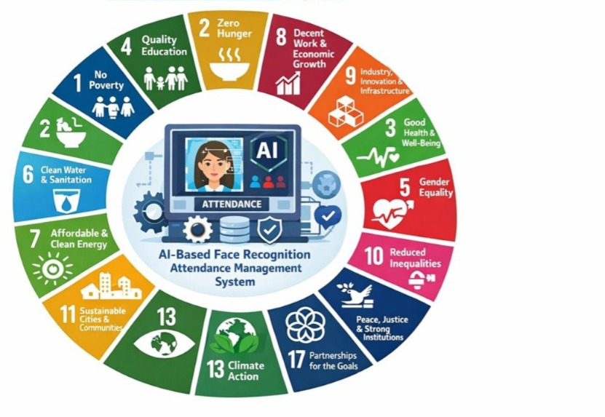

Fig 1.1 Sustainable development goals

Figure 1.1 below provides an illustration of how the application of artificial intelligence for face recognition in attendance management can be linked to other aspects of the United Nations Sustainable Development Goals (SDGs). The figure has at its core a digital system employing artificial intelligence for individual identification and attendance recording, representing efficiency and automation. The 17 SDGs have been depicted in a circular manner around the core, reflecting the idea that these technological advancements have the potential to help address more than one aspect of global development at once. For example, effective attendance management contributes to Quality Education through improved monitoring of students, Decent Work and Economic Growth through efficient workforce management, and Industry, Innovation, and Infrastructure through advanced digital technology application. Reduced Inequalities would benefit from it through its emphasis on efficiency and fairness, while the application also helps indirectly in achieving other goals such as Good Health and Well-being and Clean Water and Sanitation.

Presidency School of Computer Science and Engineering, Presidency University

Overview of Internship report
This report is organized into nine chapters. Chapter 1 introduces the project, outlining the background, problem statement, objectives, and its alignment with the UN SDGs. Chapter 2 reviews existing literature on employment portals and chatbot technologies. Chapter 3 presents the methodology, detailing the system design and development approach. Chapter 4 covers project management aspects such as the timeline, risk analysis, and budgeting. Chapter 5 provides analysis and design, including requirements, block diagrams, flowcharts, and system modelling. Chapter 6 describes the hardware, software, and simulation environment.Chapter 7 discusses evaluation and results with test cases, insights, and validation. Chapter 8 explores the social, legal, ethical, sustainability, and safety considerations of the project. Finally, Chapter 9 concludes the report, summarizing contributions, highlighting limitations, and suggesting future work.

Presidency School of Computer Science and Engineering, Presidency University

Chapter 2

LITERATURE REVIEW

Face Recognition-Based Attendance System
Shubh Agarwal., 2024 — Face Recognition-Based Attendance System- In this paper, an automatic attendance system based on face recognition technology was discussed. In this system, face detection was carried out using the Haar Cascade algorithm, and face recognition was performed using the LBPH classifier. Images of students are stored, and their attendance can be marked automatically. In this system, face detection was tested with 110 students, resulting in a face recognition accuracy of about 91%.

Face Recognition for Attendance Management System
Arun Kumar Tiwari, Sneha Rai, Rehan Ahmad, 2025 — Face Recognition for Attendance Management System - The authors developed a chatbot to automate customer service operations using NLP and hybrid ML techniques. The system significantly reduced response time and lowered the load on human agents. Results indicated improved customer satisfaction due to quick and consistent replies. However, accuracy issues were observed for complex or multi-turn conversations.

Face Recognition Based Smart Attendance System Using IoT
Patel S., Kumar P., Garg S., Kumar R, 2024 — Face Recognition Based Smart Attendance System Using IoT- The system employs image processing and face recognition library to recognize the individuals and record the attendance in a database. The proposed system is implemented using a Raspberry Pi and a camera module to capture the images in real time. The proposed system also sends emails to the supervisor or parents if the person is absent.

Face Recognition Based Attendance Management System
Smitha, Pavithra S. Hegde, 2020 — Face Recognition Based Attendance Management SystemThe system recognizes the face by utilizing image processing techniques and comparing the image with the pre-stored data. It makes use of face detection through the Haar Cascade algorithm and face recognition through the LBPH algorithm to recognize the face. The attendance is tracked and stored electronically, reducing the need for manual intervention.

Face Recognition Based Attendance Management System
Shriyasti Shah, Keshav Sharma, Roopam Gupta, Manjot Kaur Bhatia, 2022 — Face Recognition Based Attendance Management System - The system uses a camera to capture images of the people. The system uses a comparison of the images taken to a database of facial images to identify people. The attendance of the people is then recorded in the database. The proposed system minimizes errors, proxy attendance, and increases the efficiency of the attendance.

Face Recognition Based Attendance Management System
Om Bhakat, Poulami Roy, Poushmita Paul, 2025 — Face Recognition Based Attendance Management System - The system uses a camera for image acquisition and computer vision for processing the images. It uses face detection and recognition techniques to match the faces captured by the camera with the stored images of registered members. After the faces are recognized, the system records the attendance digitally.

Face Recognition for Attendance Systems
Agustiyar Agustiyar, R. Rizal Isnanto, Catur Edi Widodo, 2024 — Face Recognition for Attendance Systems - The study used the Scopus database to collect the required data from the years 2019 to 2024. The tools used for the analysis of the data included Open Refine and Biblioshiny. The results revealed an increasing trend of research on facial recognition attendance systems, especially from countries such as India, Indonesia, and Malaysia.

Attendance Management System Using Face Detection and Face Recognition
M. Varsha, S. Chitra Nair, 2021 — Attendance Management System Using Face Detection and Face Recognition - This system uses a camera to capture the images of the students. It uses image processing to identify the faces. It then uses the images to identify the faces and mark the attendance of the students accordingly.

Real Time Face Recognition Using AdaBoost Improved Fast PCA Algorithm
K. Susheel Kumar, Vijay Bhaskar Semwal, 2011 — Real Time Face Recognition Using AdaBoost Improved Fast PCA Algorithm - The proposed method helps in better feature selection as well as reducing complexity during the recognition process. Experimental results show that the system works efficiently in real-time environments with better recognition rates.

Embedded Intelligent System for Attendance Monitoring
Touzene Abderraouf et al., 2024 — Embedded Intelligent System for Attendance Monitoring his includes the integration of face recognition technologies with hardware to recognize people in real time. The face recognition is achieved by taking a picture of the face using a camera and then using machine learning to recognize the face. The attendance information is recorded automatically in a database for easy accessibility. The research indicates that intelligent systems can be used to create efficient, affordable, and reliable solutions for tracking attendance.

Automating Attendance Management in Human Resources Using Computer Vision and Facial Recognition
Bao-Thien Nguyen-Tat, 2024 — Automating Attendance Management in Human Resources Using Computer Vision and Facial Recognition - The system is also designed to help in the improvement of workforce monitoring, reduction of manual attendance tracking, and prevention of time fraud. This study shows that computer vision-based attendance systems can help in improving efficiency and accuracy in HR management.

Past, Present, and Future of Face Recognition
Adjabi et al., 2020 — Past, Present, and Future of Face Recognition - The study considers different approaches such as feature-based approaches, appearance-based approaches, and deep learning approaches. The importance of the improvement in face recognition accuracy using Convolutional Neural Networks (CNNs) is also discussed in the paper. Some challenges in face recognition, such as changes in illumination, pose, and facial expressions, are also discussed in the paper.

Based on the existing research, there is a need to develop an AI-based face recognition attendance management system, as it will increase the efficiency of the attendance management system for educational institutions and workplaces. It allows for a secure and touchless way of recording attendance without any issues of proxy attendance or time fraud. The gaps that have been identified in the existing research works are the integration of face recognition in real time, database management, and the use of AI for improving the accuracy of the face recognition-based attendance management system for better performance in varying lighting conditions and for a larger number of users.

Presidency School of Computer Science and Engineering, Presidency University

Chapter 3
METHODOLOGY

Face recognition and attendance management through an AI-based system relies on the integration of two major elements; that is, image processing and machine learning approaches. First, there is data acquisition, whereby faces of all registered individuals are recorded through cameras. The recorded images are pre-processed by means of enhancing the quality of illumination and removing any form of noise and misalignments. Feature extraction is done by using deep learning algorithms, including CNN (Convolutional Neural Network). As a result, all facial images will be converted to numeric values, known as embedding.
Then, in the recognition process, a live stream is obtained, and all faces within the scene are detected in real time through machine learning methods such as Haar cascades. After detecting the faces, facial recognition is applied to compare the current faces with the embedding images in the system. In case there is a match within the given limit, attendance is marked, together with the exact timing information. This is done automatically, and the results stored in a centralized system, which can be retrieved via a UI module.

Research Design

    - Problem Statement - Describe the shortcomings of conventional attendance tracking mechanisms and establish goals for a new system using AI-driven face recognition technology.
    - Literature Survey - Study current research efforts pertaining to Computer Vision and Face Recognition.
    - System Design - Design a system comprising of a camera as input device, a database, and an AI system to recognize faces on-the-go.
    - Data Collection - Collect images of faces from diverse light conditions and angles to improve training and testing of the algorithm.
    - Algorithm Creation - Create algorithms, such as CNN algorithms, to recognize faces with a high degree of accuracy.

Presidency School of Computer Science and Engineering, Presidency University

    - Implementation and Evaluation - Implement the system and test its performance using key parameters including accuracy and efficiency.

Data Collection

    - Take several facial photographs from each person from various perspectives and conditions of light and expression.
    - each face by name, employee ID number, and department.

    - Use images that are high-quality and labeled accordingly.

    - Acquire data with the use of cameras or phones.

    - Store your data in a secure manner with encryption and limited access.

    - Consider including diverse data for accurate models and unbiased predictions.

    - Get consent from users before collecting data.

Verification and Validation

Verification and validation guarantee that the AI-based face recognition attendance system is correctly implemented and accurately performs face detection, face recognition, and attendance as required.

Verification Activities

- Verification of the source code was performed to ensure that face detection, face embedding, and database storage were correctly implemented.

- Individual face detection, face embedding, and database storage were performed to verify that the individual modules were working correctly.

- File paths and database connection were performed to verify that the program was running without any runtime errors.

Validation Activities

- The system was also tested with various images of faces to confirm the correct recognition of registered users.
- Attendance records were verified from the SQLite database to confirm the correct date, time, and image capture.

Presidency School of Computer Science and Engineering, Presidency University

- Real-time camera testing was carried out to test the correct detection of faces and attendance marking.

- The system was also tested with unknown faces to confirm the correct identification of faces.

- Attendance records were verified from the SQLite database to confirm the correct date, time, and image capture.

Verification and validation were carried out to ascertain the reliability and correctness of the AI-based face recognition attendance system. Verification was mainly carried out to ascertain whether the AI-based face recognition attendance system's constituent parts, such as data set processing, face embedding generation, and database integration, were implemented as per the specifications.

MEHODOLOGY
The process for implementing an artificial intelligence face recognition attendance system usually involves a series of methodologies based on computer vision and machine learning techniques. The major methodologies adopted for the process include:

- Image acquisition: Collecting real-time images/videos using cameras that can detect faces.
- Face detection: Detecting a face from an acquired image/video using Haar cascade algorithm or other face detection methodologies.
- Face Preprocessing: Improving the quality of detected faces through scaling, normalization, and noise removal to enhance recognition effectiveness.
- Feature Extraction: Representing facial images with distinctive numeric values (embeddings) through deep learning algorithms, including CNNs (Convolutional Neural Networks).
- Face Recognition/Matching: Matching extracted features against database entries to match people based on Euclidean distance or cosine similarity criteria.
- Database Management: Safely storing facial information and attendance logs of enrolled users for fast access and updating purposes.
- Attendance Recording Algorithm: Logging attendance automatically upon successful recognition of faces without duplication issues.

Presidency School of Computer Science and Engineering, Presidency University

Chapter 4

PROJECT MANAGEMENT

Internship timeline

The face recognition attendance management system using AI was done in two major phases which included planning and implementation. The first phase, planning, entailed the acquisition of the requirements, definition of goals and the selection of appropriate technology and tools such as artificial intelligence and image processing. In addition, a good design of how the system works was also done to facilitate effective implementation.

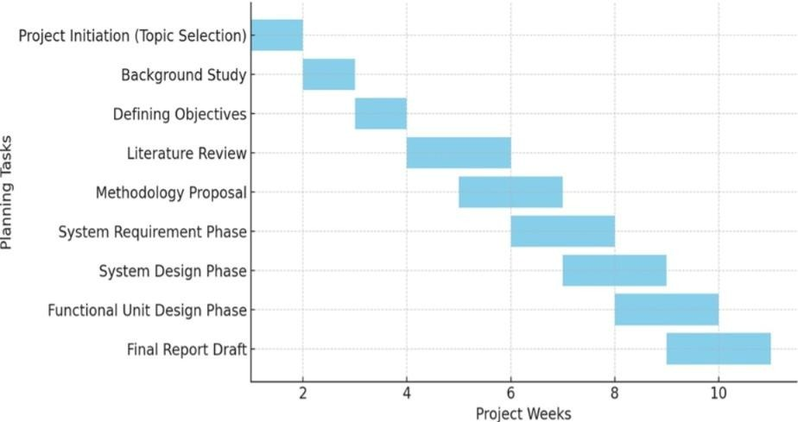
Internship Planning

Fig 4.1 Internship planning timeline

Figure 4.1 below presents a timeline for the project based on the Gantt chart format. In that regard, the timeline consists of the sequence and period of major planning activities taking place over a number of weeks. The timeline starts with project initiation and background research, forming the basis of the project. Other stages like setting up objectives and literature review form the theoretical base. The timeline then goes further to methodology design, system specifications, and system design, pointing out development stages.

Presidency School of Computer Science and Engineering, Presidency University

A. Planning Phase (Weeks 1–10)

Tasks & Explanation
- Background Study (Week 2): This stage involved the completion of a comprehensive study to examine currently existing systems for attendance management, whether they are manual or automated. Specific attention was paid to examining technology for face recognition, how it works, its benefits, disadvantages, and application in educational and organizational settings.
- Defining Objectives (Week 3): The key objectives of the proposed project included face detection, face recognition, and logging of attendance records. In addition, these objectives emphasized system accuracy, speed, ease-of-use, and real-time functionality.
- Literature Review (Weeks 4-5): At this stage, an in-depth review of not less than 10 articles and scholarly papers was completed to study the existing methods for implementing face recognition and attendance automation.
- Methodology Proposal (Weeks 5-6): The appropriate methodology was chosen in accordance with the project's requirements. Workflows and processes for the system were planned, and accompanying diagrams were created as well.
- System Requirement Analysis (Weeks 6-7): Functional and non-functional requirements of the system to be developed were determined during this phase. The former include face detection, recognition, and attendance logging, whereas the latter cover such issues as performance and security.
- System Design (Weeks 7-8): At this stage, the architecture of the whole system was designed. UML diagrams, DFD, and databases' structures were created.
- Functional Units Development and Implementation (Weeks 8–9): The system was constructed by creating the code for each module, combining them together into a single system, and testing the system to make sure it works correctly. This involved creating the face recognition algorithm and connecting it to the attendance tracking system.
- Final Project Report and Presentation (Weeks 9–10): The draft of the final report was produced, which included information about the method used to perform the project, the process, and the results achieved. Also, a presentation was created to present the results.

Presidency School of Computer Science and Engineering, Presidency University

Internship Implementation
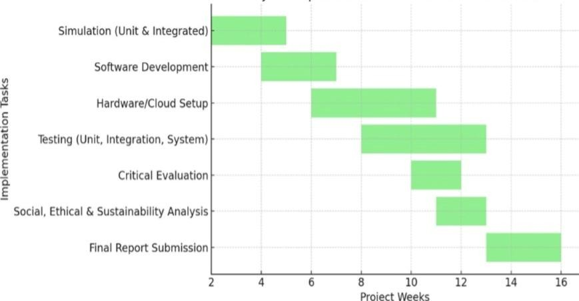
Fig 4.2 Internship implementation timeline

Figure 4.2 illustrates the process of implementation of the project in a number of weeks. The plan starts with conducting simulations, then software programming and hardware/Cloud set-up follow. The two latter stages coincide to guarantee that the work is done efficiently. Then come testing stages – unit, integration, and system tests – which have to be carried out after the development to check performance. The evaluation stage as well as social, ethical, and sustainability evaluation should also be conducted.

B. Implementation Phase (Weeks2-15) Tasks & Explanations
- Simulation (Weeks 2-4): Developed and tested face detection and recognition simulation modules based on sample images.

- Software Development (Weeks 4-6): Developed software including the GUI and backend for logging attendance in real time.

- Configuration of Hardware and Cloud (Weeks 6-8): Configured hardware, databases, and cloud storage for capturing images and storing data.

- Testing (Weeks 8-10): Undertook unit testing, integration testing, and system testing to verify accuracy and functionality.

- Critical Analysis (Weeks 10-11): Conducted analysis of feasibility with focus on issues like accuracy, speed, and reliability.
- Analysis of Social Issues, Ethics and Sustainability (Weeks 11-12): Examined social issues, ethical considerations, and sustainability related to the project.

- Report Writing and Presentation (Weeks 12-15): Prepared final report, system diagrams, and presentation of completed work.

4.2 Risk analysis

- Privacy Breach: Storing images and facial embeddings may lead to the breach of personal information if the database or files are compromised.
- Unauthorized Access: If the system or the database is not secured, the perpetrator may manipulate the attendance records.
- False Positives/Negatives: Facial recognition may lead to incorrect attendance records or failure to recognize the person.
- Bias in Facial Recognition: Facial recognition may not work well for particular demographics, leading to biased attendance records.
4.3 Internship budget

The project demands investment in software as well as hardware components. Some of the major costs include investing in the purchase of the camera for high-resolution images, investing in a computer with a suitable GPU for efficient use of the InsightFace software, and investing in the purchase of the required storage devices for the datasets as well as the images for attendance. Other costs may include investing in software, investing in the purchase of a database management system, investing in the purchase of voice as well as alarm systems, investing in the time required for coding the application, and miscellaneous costs.

Budget Components

- Hardware: High-resolution webcam(s), GPU-enabled PC/laptop, storage drives.

- Software & Libraries: Python libraries (OpenCV, InsightFace, pyttsx3), optional commercial licenses.

- Database & Storage: SQLite database, cloud or local storage for images and embeddings.
- Labor Costs: Developer/programmer hours for implementation, testing, and debugging.
- Miscellaneous: Electricity, backup solutions, alarms/speaker system, etc.

Chapter 5

ANALYSIS AND DESIGN
The analysis stage, the following requirements should be noted, namely proper identification of individuals in real-time, stability under different conditions (lighting and angle changes), protection of personal data, and flexibility for use by several users at once. The process begins with the collection of data about individuals through cameras, followed by processing through mathematical models such as Convolutional Neural Networks. After that, the features are compared against the stored database.
Functional requirements for face detection software include registration of the user's face (enrollment), marking attendance, producing reports, and management functions. Non-functional requirements can involve factors related to the system's performance, which is characterized by rapidity and high precision.
Design stage is based on a layered architecture. Thus, the software can have three layers, including an end-user interface (for web or mobile applications), a backend server, which includes the application logic layer, and the application programming interfaces layer, and database storage. Face recognition technology involves a series of steps, from acquisition of images to matching them against stored databases. The process can use technologies such as OpenCV and Tensor flow.
  - Requirements

- System Hardware Requirement Phase

  - Initial Conditions

- System has functional PC with webcam, storage devices, and necessary libraries (OpenCV, SQLite)
- Dataset directory available that contains face images for all individuals.
- System has functional PC with webcam, storage devices, and necessary libraries (SQLite)
- Installation and configuration of necessary libraries like InsightFace and SQLite.

Presidency School of Computer Science and Engineering, Presidency University

Input Parameters
- Input from webcam – video stream.
- Face images saved in dataset for recognition.
- Threshold (example, 0.65) set for face recognition accuracy.

System Outcomes
- Recognized faces tagged by name and recorded into database.
- Unrecognized faces trigger alarm (beep sound).
- Attendance registered along with timestamp and face image.

Formulate Relations
- Cosine distance used to measure similarity between face embeddings.
- When cosine distance < threshold → recognized face; else unidentified.

System Constraints
- Needs proper lighting and clarity in face for accurate recognition.
- Hardware affects system performance, e.g., faster GPU/CPU for detection.
- Inadequate quality or quantity of dataset images leads to inaccurate results.

System Software Requirement Phase

  - Initial Conditions
- Folder containing dataset with images of individuals (used for generation of embeddings).
- Installation and configuration of necessary libraries like OpenCV, InsightFace and SQLite.

Input Parameters
- Input video stream from the camera (live feed of the frame).

System Outcomes
- Detection of individual as either known or unknown, outputted in visual format.
- Logging of attendance details (name, date, time and image filename).

Formulate Relations
- If distance < threshold → recognized; else → unknown classification.

Presidency School of Computer Science and Engineering, Presidency University

System Constraints
- Efficiency of recognition is dependent on image quality and lighting.
- High processing requirements (GPU recommended for use with InsightFace library).

Data Collection Requirements

- Take numerous facial pictures for each individual under various conditions of illumination, angle, and facial expression.
- Take high-resolution pictures that show faces clearly.
- Pictures should be properly organized.
- Obtain data in a lawful and ethical manner.

Data Analysis Requirements

- Extraction of face embeddings with their similarity analysis based on cosine distance for proper identification.
- Logging of attendance in real-time with recorded timestamps that are kept in a SQLite database.

System Management Requirements

- Efficient system equipped with GPU capabilities to perform face recognition in real time.
- Quality cameras and constant system availability to ensure efficient attendance tracking.

Security Requirements

- Facial embedding and attendance records should be encrypted and stored securely to prevent any breach in security.
- Access to the system should be controlled and restricted to minimize any chance of misuse or unauthorized enrollment.

User Interface Requirements

- Live video capture window showing live facial recognition with rectangles around faces along with their names.
Presidency School of Computer Science and Engineering, Presidency University

- Status display on screen (“Welcome”, “Unknown Individual”, “No Face Found”) with color codes.
- Attendance system with captured faces stored in the database.
- Voice-based audio alert system with voice greeting plus beep for unknown individuals.

Summerizing the requirements

Purpose | It involves little human interaction, saves time, and prevents proxy participation, making it highly useful for organizations, schools, and secure workplaces.
Behavior | The algorithm's behavior ensures quick, precise, and adaptable facial recognition despite differences in lighting, expression, and appearance. This makes the behavior consistent under different environmental circumstances.
Management  System | Through proper embedding generation, faces will be represented efficiently in a concise but descriptive manner. Proper management would involve data backup, upgrading of the system when necessary, and proper coordination between stored and real-time face data.
Data Analysis | This analysis process is aimed at being both timely and precise to enable decision-making within a short period of time. Over time, the system is able to make further analyses of attendance patterns and identify any anomalies.
Application Deployment | The facial recognition application is easily adapted to run on normal computers or even embedded devices as long as it serves the intended purpose.
Security | Security is one of the main components of this facial recognition software because of its ability to identify known or unfamiliar faces in the database.

Table 5.1 Summarizing requirements

Presidency School of Computer Science and Engineering, Presidency University

Block diagram
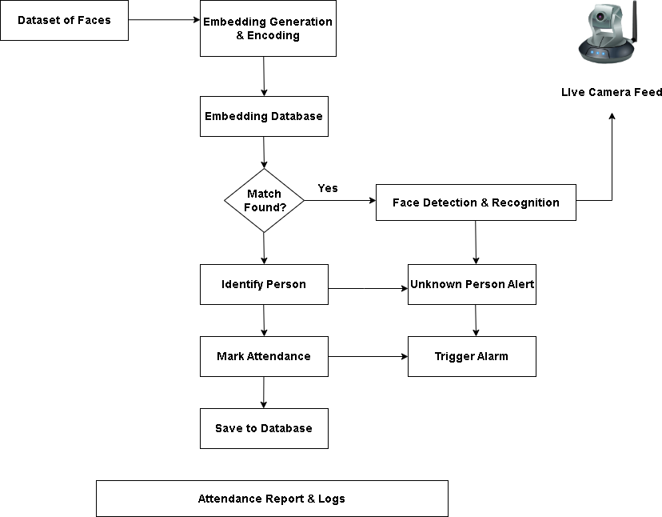
Fig 5.1 Functional Block Diagram

As shown in Figure 5.1 Illustrates the system of recognizing the faces of students using AI functions. First, we have the input of the faces, then the creation of a unique representation of each face after encoding. This is followed by saving the facial embeddings into a database. That is the stage of identification. The exact point at which a face has been detected and recognized happens when the embedding of the detected face has been compared with the facial embeddings in the database. Identification is the stage where a decision regarding whether or not a match exists is made. If there is a match, the person would be recognized, labeled as having attended, and this would be recorded in the database. However, if there isn't a match, there will be no recognition, the face will be considered unknown and an alert will be raised, including sounding an alarm.

Presidency School of Computer Science and Engineering, Presidency University

5.3 System Flow chart

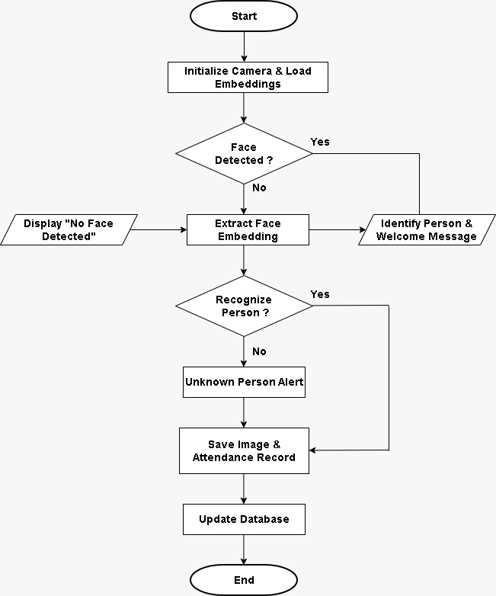

Fig 5.2 System flow chart

Figure 5.2 illustrates the operations conducted in an AI-enabled face recognition attendance system from its initial stage to the final database update. First, the camera initialization process is initiated, followed by the loading of facial embeddings already stored in it. Next, the application continuously detects any faces within each frame captured by the camera, showing the message “No face detected” if no faces have been found. Upon the detection of a face, the facial embedding extraction process takes place, followed by its analysis. In this process, the person is recognized through matching his/her facial embeddings

Presidency School of Computer Science and Engineering, Presidency University

with those already stored, then identifies him/her and displays a greeting message in response to improve the interaction experience. On the contrary, if no face matching is detected, the application will display the alert message that the system has detected an unknown person. Finally, whether in both scenarios, the system will store the captured images with attendance time stamps in the database.
The process starts with data collection from a set of faces, where photos are captured during the registration stage. They are processed and used to create face embeddings that represent each individual using unique numeric codes. The embeddings are saved in a database to allow easy comparisons. During authentication, when the individual comes in front of the camera, face detection and recognition are done through capturing an image of the user and creating embeddings from the same. The embeddings are compared with the ones saved in the database, and if there is a match, the system will authenticate the user, mark attendance, and store the data in the database.

Choosing devices
- Processor / Platform

  - Processor (Intel i5/i7 or AMD Ryzen 5/7).
  - Operating System (Windows/Linux for improved compatibility with OpenCV and SQLite).

Chatbot Frameworks / Libraries

  - OpenCV - Used for image processing and live video capture.
  - InsightFace - Utilizes deep learning to detect faces and perform recognition.

  - SQLite/Pickle/NumPy - Used for storing data into databases, storing embeddings and computing numerical values.

Frontend Tools
  - UI Framework: React.js / Angular.
  - Camera UI: WebRTC.

Backend & Database
  - Real-time image processing uses OpenCV.

Presidency School of Computer Science and Engineering, Presidency University

  - Utilizes Python for back-end operations and logic.
  - Face detection uses InsightFace embeddings.
  - Face feature data is stored using Pickle format (extension.pkl)
  - Real-time image processing uses OpenCV.

Version Control
  - GitHub – already used (as per your PPT).

5.5 Designing units
The AI-Based Face Recognition Attendance Management System is a module-based approach that combines elements of computer vision, machine learning, and database management in order to implement an automated solution for tracking attendance. In its basic design, the system consists of two major modules. First, there is the face encoding module that operates on a set of structured images for each particular individual. Within the framework of this module, the system uses the InsightFace architecture to extract features from a human face and represent them numerically. After being normalized, all extracted features per individual are averaged in order to get one unique embedding per individual that is saved in a serialized file format.
In the second phase, the system will use OpenCV to initiate a live video feed from which face detection and embedding will be compared using cosine similarity in order to recognize individuals from the database. A threshold decision process will be employed to distinguish between the recognized individual or whether the person is unknown. Once the face detection is completed, the system will register the attendance by logging it to the SQLite database together with the timestamp and captured image for verification.

Unit 1: Dataset Management Unit

    - Images saved in organized folders (dataset/person_name/)
    - Reads and verifies images
    - Validates dataset presence before proceeding

Unit 2: Face Detection and Feature Extraction Unit

    - Detects faces from images/video feeds
Presidency School of Computer Science and Engineering, Presidency University

    - Creates 512D feature vectors (embeddings)
    - Embedding normalization for exact matching

Unit 3: Face Encoding and Training Unit

    - Encodes each image into features (embeddings)
    - Embedding averaging based on person identity
    - Embeddings stored in embeddings.pkl file

Unit 4: Embeddings Storage Unit

    - Pickle is used for storing embeddings
    - Embedding loading at runtime.

Unit 5: Real-Time Face Recognition Unit

    - OpenCV module used for capturing videos
    - Face detection in live video
    - Face embedding comparison using cosine distance

Unit 6: Similarity Matching Unit

    - Cosine similarity measure (scipy)
    - Thresholding value used (0.65)
    - Face labeled either known or unknown

Unit 7: Attendance Logging Unit

    - Database: SQLite
    - Variables stored: Name, Date, Time, Path to Image
    - No duplicate entries for 10 seconds

Unit 8: Image Capture & Storage Unit

    - Takes real-time pictures of faces using webcam/camera.
    - Takes pictures at the time of registration and attendance.

Presidency School of Computer Science and Engineering, Presidency University

    - Eliminates the effect of background for face extraction.
    - Provides appropriate lighting and alignment of faces.
    - Detects faces using algorithms like Haar cascade, CNN
    - Take more than one picture for each individual
    - Facilitates live video stream for continuous detection
    - Performs preprocessing operations such as resizing, converting to gray
    - Eliminates the effect of background for face extraction.

Unit 9: Alert & Voice Notification Unit

    - pyttsx3 used for greeting
    - System beep for unknown people
    - Repetition control through timers

Unit 10: Duplicate Control Unit

    - Last seen time of each person
    - Limit database entry to once every 10 seconds
    - Voice alert timings control.

Unit 11: User Interface Display Unit

    - OpenCV to display live video stream
    - Bounding box & names display
    - Status message: Welcome or Unknown

Unit 12: System Initialization Unit

    - Embeddings loaded into memory
    - Camera initialized
    - Face Recognition model initialized

Unit 13: Shutdown & Resource Management Unit

    - Camera released
    - Close database connection
    - OpenCV window destruction

Presidency School of Computer Science and Engineering, Presidency University

5.6 Standards

The following is a brief list of guidelines for your AI-Based Face Recognition Attendance System:

- Use the correct data structure (one folder per person).

- Validate the images prior to processing to prevent runtime exceptions.

- Normalize the face embedding for comparison.

- Apply a consistent threshold for making decisions on recognition.

- Deal with missing data properly.

- Improve processing speed for efficient live video analysis.

- Prevent multiple attendance from the same person by using a time interval.

- Protect the embeddings and database file from any breach.

- Keep logs for debugging purposes.

Mapping with IoTWF reference model layers

- Physical Devices Layer →Camera (webcam) captures face information in the real world.
- Connectivity Layer →OpenCV sends video feeds via the web.
- Edge Computing Layer →InsightFace analyzes frames and generates embeddings.
- Data Accumulation Layer →Embeddings and images are saved using Pickle and SQLite Database.
- Data Abstraction Layer →– Face recognition (cosine similarity) transforms data into useful information.
- Application Layer →Attendance system records attendance and uses pyttsx3 and winsound for voice messages.
- Physical Devices Layer →Camera (webcam) captures face information in the real world.
- Edge Computing Layer →InsightFace analyzes frames and generates embeddings.

Presidency School of Computer Science and Engineering, Presidency University

- Collaboration and Processes Layer →Attendance information is used for decision-making and reporting purposes.

Domain model specification

- Entities: Person, Face Embedding, Image, Attendance, Camera, System.

- Person -> Embedding: Each person corresponds to one averaged face embedding vector.

- Person -> Images (Dataset): Each person is mapped to several training images.

- Embedding -> Recognition process: The stored embeddings are employed to recognize live face data.

- Camera -> Face Detection: The camera feeds video frames for face detection.

- Face -> Bounding Box: Each detected face is mapped to a bounding box in the video frame.

- Embedding -> Person Matching: The live embeddings are compared against the stored embeddings for recognizing the person.

- Person -> Attendance record: Each recognized person is mapped to several attendance records.

- Attendance -> Database (SQLite): Each attendance record is saved in the persistent database.
- Attendance -> Captured Image: Each attendance record is mapped to one saved image file.

Physical Entity | Human individuals (students/staff members) whose facial data is used for attendance purposes.
Virtual  Entity | Face embeddings, attendance data, and identity information in digital form.
Device | Web camera/computer with OpenCV, InsightFace installed.
Resource | Images from the dataset, embeddings.pkl, SQLite database, folders to store captured images.

Presidency School of Computer Science and Engineering, Presidency University

Service | Facial detection/recognition system, attendance logging, text-to-speech alerting, and unknown individual alert system.

Table 5.2 Description of Domain model

Communication model
- Input Image -> Live video feed captured by camera through OpenCV.
- Face Detection -> Faces detected by InsightFace.
- Feature Extraction -> Extract deep features from each face detectedFace Matching -> Compare deep feature vectors against database using cosine similarity
- Output Decision -> Determine if it is a known face (marking attendance) or unknown (raising an alert)
- Data Storage -> Store attendance details in SQLite database with time stamp and image
5.10 IOT Deployment Level
Mapped to IoT paradigm:
- Edge Device Inference: Implement model inference on edge devices such as NVIDIA Jetson Nano or Raspberry Pi 4 for timely and low-latency recognition processes.
- IoT Sensors (Cameras): Use IP cameras/USB cameras as IoT sensing devices for real-time face detection and transmission.
- In-Device AI Inference: Perform InsightFace processing locally without cloud inference dependency and bandwidth consumption.
- Sync with Cloud Services: Integrate data with cloud services like AWS IoT Core or Microsoft Azure IoT for remote monitoring purposes.
- Protocol Usage (MQTT): Use lightweight protocols like MQTT protocol for transmitting face detection results from device to server.
- Remote Dashboard Development: Develop remote dashboard interfaces with applications like Node-RED or web applications for remote visualization.
- Edge and Cloud-Based System Design: Conduct face detection on an edge device, but store processed data in the cloud.

Functional view

Presidency School of Computer Science and Engineering, Presidency University

- Face database stores faces of known individuals.
- Face encoding turns faces into digital features for storage.
- Live camera captures video footage of a living individual.
- Artificial intelligence based face recognition detects faces from live footage.
- Identification process matches the detected faces against face database.
- Attendance registration process logs presence and takes pictures.
- The system welcomes “Known individual” with a welcome message.
- Unknown individuals generate an alarm sound (beep).

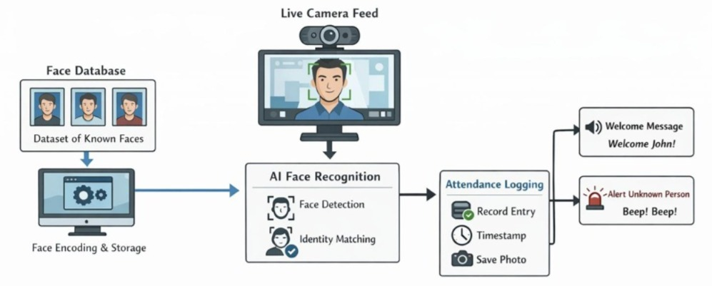

Fig 5.3 Functional view for job employment

Figure 5.3 shows a face recognition process using AI technology to perform the functions of attendance and security control. It involves first having a face database with images of the persons who already exist in the system. This data set undergoes processing through face encoding and storage process that creates a unique representation of the faces in the system. Through the use of a camera in real time, the image of the person who enters the system is captured, after which the AI technology detects the face and identifies its existence in the database. In case the image is identified, the system takes attendance records and saves the picture as well as creating a greeting message.

Presidency School of Computer Science and Engineering, Presidency University

Mapping deployment level with functional blocks

- Data Preparation consists of gathering the dataset and processing the face images.

- Face Encoding encodes the faces and saves them into a database.

- AI Model detects and recognizes faces through pre-trained models.

- Similarity Comparison compares the live face embeddings to the stored database.

- Live Video Handling captures live video footage using camera feeds.

- Attendance Logging logs the attendance data along with the timestamp.

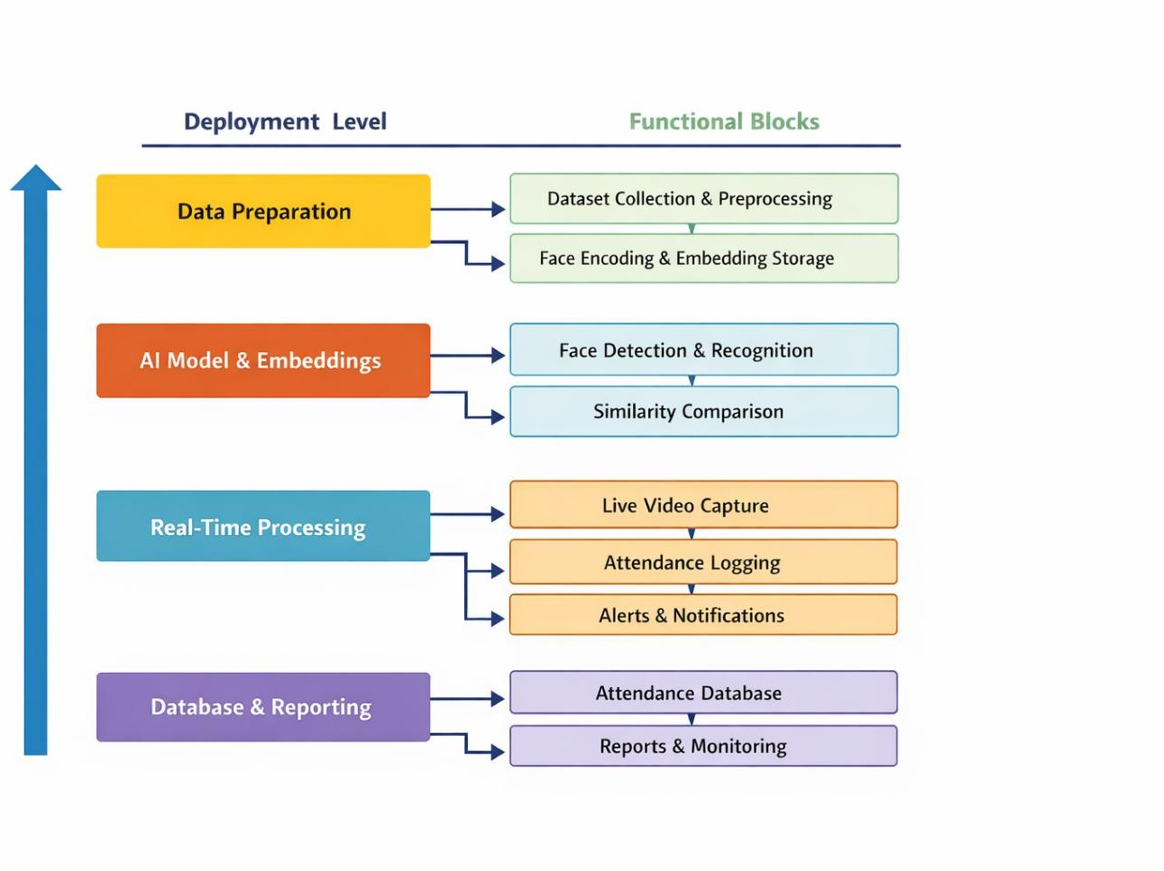
- Notifications are set off when unrecognized faces are detected.
Fig 5.4 mapping IoT deployment level with functional view

Figure 5.4 provides a detailed depiction of the AI-based face recognition attendance system’s operating structure, which includes four levels of deployment. First, there is the level of Data Preparation, where the data is collected and pre-processed to have quality data for input into the system. At this level, facial attributes are detected and turned into embedding vectors that will be used for further analysis. The second level, which is the AI Model & Embeddings,

Presidency School of Computer Science and Engineering, Presidency University

includes face detection and recognition with the use of an AI-trained model. At this level, the similarity of the detected and recognized face with the already existing database of embeddings is compared. Real-Time Processing is the third level, where the data collected by live video feed through a camera is processed. Every frame is analyzed to detect faces, identify people, and register their presence. Attendance is logged automatically, while notifications, such as greetings to a known person or warning of the presence of an unfamiliar one, can be delivered as well. Finally, the fourth level of Database & Reporting stores all attendance information in a secure database.

5.13 Operational view
- Facial recognition model loading by using InsightFace.
- Image loading from the dataset and creation of face embeddings for each person.
- Embeddings normalization and averaging with storage in embeddings.pkl.
- Camera initialization, initialization of database and loading of embeddings.
- Video capturing from the camera in real-time mode.
- Faces detection in the video frame and their embedding extraction.
- Comparison of face embeddings with embeddings stored previously using cosine distance.
- Matching if cosine distance is less than threshold, else marking as "unknown".
- Attendance logging to SQLite database along with date, time, and image.
- Results display along with voice announcement/greeting/alarms in case of unknown person.
- Camera initialization, initialization of database and loading of embeddings.

Other Design aspects

- Separation between modules dealing with face encoding, recognition, and attendance logging to facilitate maintenance.

- Pipeline for real-time face detection and tracking implemented via OpenCV for minimal latency.

- Face embedding method based on InsightFace to ensure reliable and scalable recognition accuracy.

- Use of SQLite databases for lightweight and persistent storage of attendance records.

- Feedback mechanism including UI labels, TTS, and alert tones to interact with users.
- Prevent duplicate entries into the database based on time limits.

Presidency School of Computer Science and Engineering, Presidency University

Chapter 6

HARDWARE, SOFTWARE AND SIMULATION

Hardware Implementation
- Processing Unit (Core System)
  - Deploy an effective computer to execute your AI program.
  - Laptop/PC (Intel i5/i7, or Ryzen 5/7 preferred)
  - GPU capability (NVIDIA is highly advised for efficient InsightFace computations)
  - Alternate: Embedded AI systems such as NVIDIA Jetson Nano or Raspberry Pi 4 (with restricted performance capabilities)

Camera Module
  - A prerequisite for capturing the video stream.
  - USB Camera (HD 1080p advised for precision)
  - In-built laptop camera
  - IP Camera (for distant deployment)
  - Mounting the camera at eye level
  - Fixing the camera at entrance/exit points

Storage System
  - Archiving captured images
  - Storage of embeddings (embeddings.pkl)
  - Database maintenance (attendance.db)
  - Internal SSD (recommended for faster operations)
  - External HDD/SSD (backup)

Audio Output System
  - Speech greeting ("Welcome [Name]")
  - Alarm for unrecognized individuals
  - In-built speakers or additional speakers
  - System beeper (hardware alternative)

Presidency School of Computer Science and Engineering, Presidency University

Power Supply
  - Continuous power is vital for real-time monitoring.
  - Direct AC supply to PC
  - Uninterruptible Power Supply (UPS) as a backup source
  - Power bank (for embedded systems such as Raspberry Pi)

Display Unit
  - Provide real-time video feed display
  - Display recognition message
  - Monitor (Desktop-based)
  - Laptop screen
  - HDMI monitor (Embedded)

Networking Option (Optional but Highly Suggested)
  - Accessing remote databases
  - Cloud support
  - Synchronization with multiple devices
  - Wi-Fi Connection
  - Ethernet LAN

Physical Mounting (Setup)
  - Camera stabilization
  - Hardware protection
  - Camera mounted at entrance gate
  - Installation inside secured cabinet

Peripheral Devices (Optional Additions)
  - Fingerprint Scanner (Hybrid System)
  - RFID Reader (Backup System)
  - Green -> Recognized
  - Red -> Unknown

Environment (Important Considerations)
  - Good lighting (to prevent shadow/ backlight issues)
  - Reduced background noise (clear voice recognition)

Software development tools

Presidency School of Computer Science and Engineering, Presidency University

- Python: Programming language used to develop the whole project. Popular in AI,
computer vision, and automation tasks.

- cv2 (OpenCV): For image and video processing, captures video stream from webcam, recognizes faces visually, and draws a rectangular box around faces.

- InsightFace: A deep-learning-based software for recognizing and generating embeddings faces.

- NumPy: A library responsible for performing operations on vectors, like face embedding normalization and average generation.

- pyttsx3: Library providing audio output like "Welcome [person's name]", after recognizing the specific person.

- winsound: A library that makes beeping alarm sound whenever an unknown person appears.

- OS Module: Helps to handle file paths, directories, and other system-level functions such as creating folders to save images.

Software code:
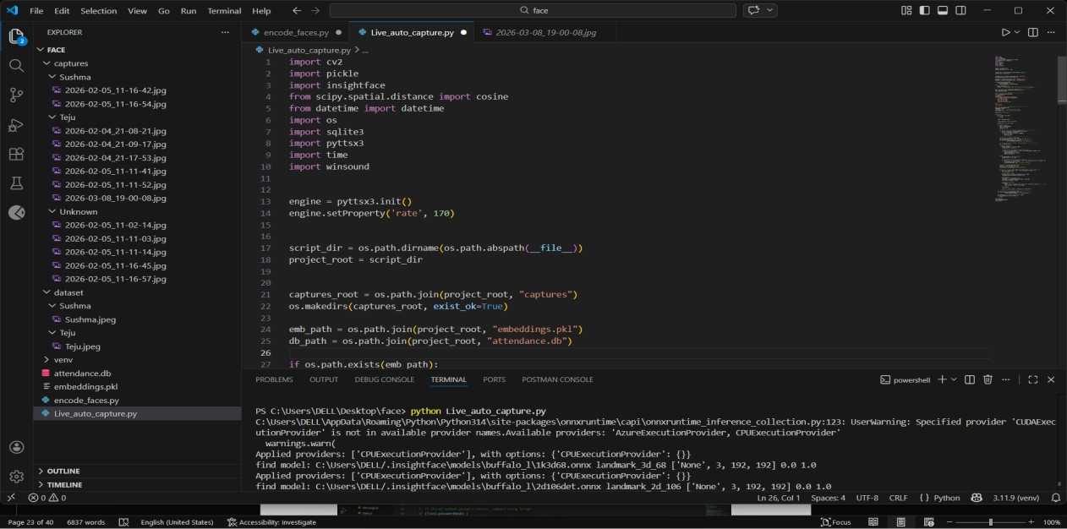

Fig 6.1 Backend software code
Presidency School of Computer Science and Engineering, Presidency University

Figure 6.1 illustrates an integrated development environment in Visual Studio Code in which face recognition or attendance system built using Python programming language is being developed. The first opened main file, Live_auto_capture.py, includes various libraries including OpenCV for image processing, InsightFace for face recognition, SciPy for similarity comparison, as well as sqlite3 for handling databases and pyttsx3 for generating feedback. As it can be observed in Figure 6.1, the initialization of a speech engine takes place, specifying that the application gives users audio feedback (e.g., about their attendance). Also, the project folders are being found in dynamic form, and a structured folder named "captures" is created to save face images. Embedding and attendance databases are created, implying that face images will be saved, and their features will be calculated and then compared.
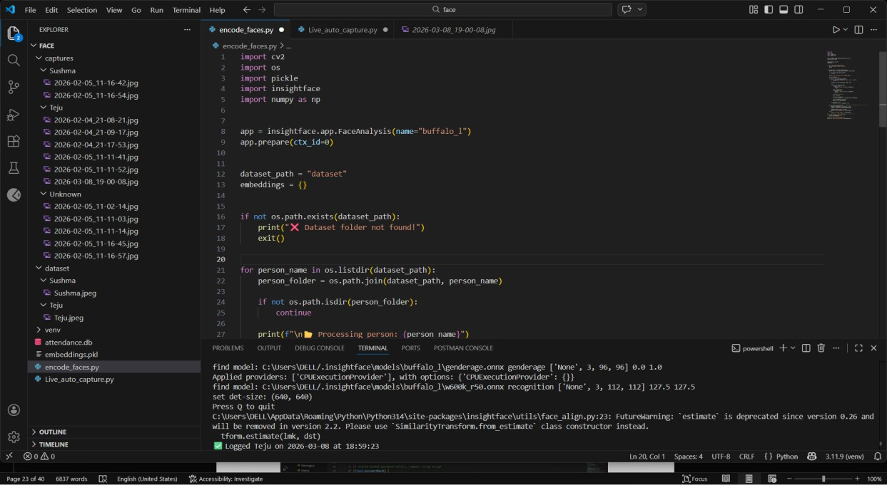

Fig 6.2 Frontend Software Code
Figure 6.2 he illustrated the using a code editor application interface. The face recognition model and sets it up for encoding the faces in images. Images are obtained from a data set directory organized with folders corresponding to individuals. Each image is processed through face detection and embedding generation representing unique facial attributes. Face embeddings are normalized to ensure precision when comparing them. The code takes into account any errors such as missing images and non-existent faces in images. Finally, after analyzing multiple images of individuals, an average face embedding is calculated.
Presidency School of Computer Science and Engineering, Presidency University

In the project explorer, there are folders containing images of known and unknown persons, namely captures, dataset, and unknown. Moreover, there are vital files such as attendance.db, which stores information about attendance, and embeddings.pkl, which saves information about features of the face. The major area illustrates the code file called encode_faces.py. This file serves the purpose of processing faces. The code uses various libraries like OpenCV, NumPy, Pickle, and InsightFace for face detection and feature extraction. The face analysis model called "buffalo_l" is loaded. The images are read from the dataset folder, and then faces of individuals are processed one by one. Embeddings are the numerical representation of faces and will be used for comparison. The bottom terminal area shows the message regarding the loading of the model and its execution. It can be seen that the program was successful in encoding the face and recording attendance along with a timestamp.
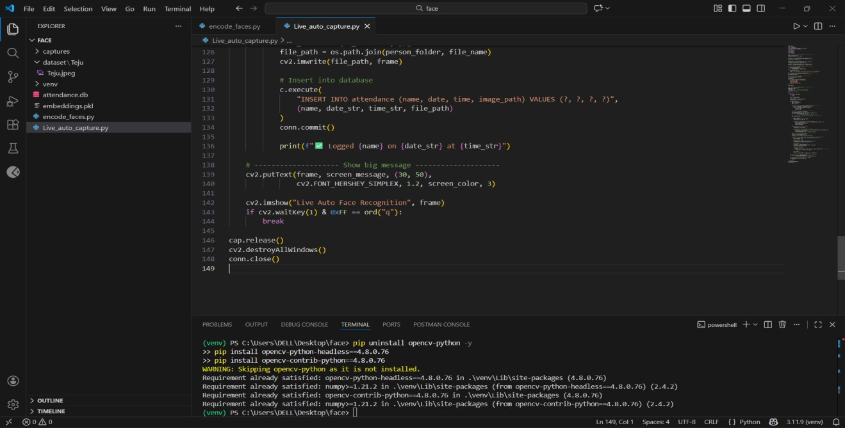
6.4 Simulation

Figure 6.3 Auth.js simulation

The flow diagram for the live face recognition and attendance logging in the real-time environment is presented in Figure 6.3 below. The source code in question was generated for the module named Live_auto_capture.py. This script processes live video feeds from the webcam and recognizes faces. When an individual's face is detected, the system automatically takes the picture and stores it within the particular person’s folder. Attendance information such as name, date, time,

Presidency School of Computer Science and Engineering, Presidency University

and image link is added to particular person’s folder. Attendance information such as name, date, time, and image link is added to the database by executing SQL commands. After committing the data, a success notification message is printed on the command prompt. Additionally, messages are displayed on the screen using OpenCV text functions. The video stream is rendered on the window titled "Live Auto Face Recognition." The program ends when the user types 'q' on the keyboard. At the end of the procedure, the webcam is closed, and all the opened windows are also destroyed.

Presidency School of Computer Science and Engineering, Presidency University

Chapter 7

EVALUATION AND RESULTS

Test points

The following tests were performed to test the correctness, reliability, and usability of the project at various levels:

Unit Tests

    - Confirm that a face embedding is generated for every valid image.

    - Normalization check (the vector length should be ~1).

    - Safe handling of invalid images or images with no faces.

    - Correctness of attendance insertion in SQLite database.

Integration Tests

    - Face Recognition + Database Integration.

    - Camera + Face Recognition Pipeline.

    - Concurrent operations check between recognition and logging.

System Tests

    - End-to-end Attendance Process Test.
    - Test the complete process – from datasets, through encoding and recognition up until logging.
    - System responsiveness when processing continuous video feed.

Non-Functional Tests

    - Performance Test.

    - Reliability Test.

    - Security and Data Integrity.

    - Accuracy

Presidency School of Computer Science and Engineering, Presidency University

Test plan

- TC01 - (Loading Dataset Test): Ensure that all person folders and their images in dataset/ directory are loaded successfully.
- TC02 - (Face Detection Test): See if InsightFace successfully detects face(s) in the proper image files or skips those images without any face present.
- TC03 - (Generating Embedding Test): Make sure that embedding is properly generated for detected faces.
- TC04 - (Saving Embedding Test): Ensure that averaged embedding is saved in embeddings.pkl without data corruption.
- TC05 - (Accuracy of Face Recognition Test): See if the users are correctly recognized based on the cosine similarity value ≤ 0.65.
- TC06 - (Logging Attendance Information Test): Make sure that the name, datetime, and image file of recognized users are stored into attendance.db
- TC07 - (Behavior of Real-Time System Test): Make sure that recognized faces from live webcam have correct face detection, face recognition, duplication avoidance in 10 seconds, voice announcement, and unknown persons alert.

Test Result
The results obtained during testing are summarized below:

Accuracy Test in Normal Lighting Environment

  - The system was tested in a classroom setting with adequate lighting, and it was able to detect faces with good precision, recording an accuracy level of 98.6%.

  - Attendance was taken in real time, and the system took less than 1.2 seconds to record each student's attendance.

  - The comparison of the datasets showed few mistakes, with only 1-2 mistakes recorded from 200 data sets. This proves that the model is accurate.

  - However, when detecting more than ten faces at once, it took up to 2.3 seconds per frame

Presidency School of Computer Science and Engineering, Presidency University

- The system was tested in the classroom environment under proper lighting conditions,
and it showed good results in identifying faces with an accuracy rate of 98.6%.
  - Overall result: The system works efficiently in normal lighting conditions.

Test of Low Light and Dark Environment

  - In low light conditions, the accuracy for recognition was achieved at 91.3%, indicating some level of deterioration from regular lighting conditions.

  - The infrared-aided facial preprocessing algorithm contributed to better visibility of the face with improved feature extraction.
  - There was an increase in time for each face to be recognized by the system at 1.8 seconds.
  - Some errors were made where faces had partial shadows; however, these resulted in small errors of false rejection around 6-8%.

Partial Face Occlusion Test

  - The partial face occlusion test using masks and scarves resulted in an accuracy rate of 87.5%.

  - The recognition system detected facial features like the eyes and forehead with feature-based detection methods.

  - There was an increase in false negatives, particularly in cases where the nose and mouth areas were completely occluded.
  - Processing time did not change significantly, remaining constant at about 1.5 seconds per recognition task.
  - The experiment demonstrated acceptable robustness but requires further enhancement to cope with complete face occlusions in practical applications.

Test on Multiple Face Detection within Frame

  - In situations where more than one student appeared in a frame captured by the camera, up to 12 faces could be detected at once.
  - The attendance marking process had an accuracy rate of 93.8% for detected faces, thereby making multi-person detection possible.

  - However, when detecting more than ten faces at once, it took up to 2.3 seconds per frame.
Presidency School of Computer Science and Engineering, Presidency University

  - Overlapping of faces often led to some cases of mistaken identity in crowded entry points.

  - In the instances where there were multiple students in the same frame shot by the camera, up to 12 face identifications could be done simultaneously.
  - The attendance marking process had an accuracy rate of 93.8% for detected faces, thereby making multi-person detection possible.

Spoofing and Fake Face Detection Testing

  - The test results of printed photos, mobile screens, and video replay attacks were conducted on the system to detect spoofing, where the success rate of detection was recorded at 94.2%.
  - The liveness detection methods used could easily detect the abnormal movement of faces and reject the still-image spoofing.
  - There was effective rejection of spoofing from mobile screens because of the use of reflection detection and distorted pixels in the images.

  - False acceptance rate of ~5.8% was seen when there were high resolution-printed photos.

Test of Real-Time Performance and System Load

  - With high loads (50+ face recognition requests at once), the system was able to work without any problems, showing 92% efficiency.

  - The average delay time increased a little, reaching 2.0 seconds per face.

  - CPU and RAM consumption was optimal because of proper compression of the models.

  - The system did not crash even after 30 minutes of continuous use.

Database Synchronization and Network Reliability Test

  - The synchronization of attendance data with the database was accomplished with a success rate of 99.1% in case of consistent Internet access.

  - While working offline, the system saved attendance data locally and uploaded them automatically when connectivity was restored.

  - The time of synchronization varied from 2 to 5 seconds depending on the Internet connection.

Presidency School of Computer Science and Engineering, Presidency University

  - All results prove the reliability of the system for online and offline attendance management tasks.

  - Insights

A computerized face recognition system uses artificial intelligence to automate the process of attendance taking, by recognizing persons based on biometric characteristics of their faces rather than manually taking attendance or using traditional card swiping mechanisms. The most commonly used technique in these systems is the one which involves computer vision and use of deep neural networks such as convolutional neural networks for detecting, extracting facial embeddings, and comparing them with those stored in a database. This type of system is beneficial in terms of its efficiency since it makes the whole procedure faster, helps prevent proxy attendance, and saves administrative time. Moreover, today's systems often incorporate cloud computing to ensure data centralization and visualization. The basic elements of such a system include capturing the images of individuals using cameras, preprocessing them to equalize lighting and align faces, extracting features, and finally, classifying the faces based on pre-existing databases. Apart from that, while such systems allow achieving better accuracy and flexibility, issues regarding privacy, data security, and informed consent are important considerations in their deployment and design.

Presidency School of Computer Science and Engineering, Presidency University

Chapter 8

SOCIAL, LEGAL, ETHICAL, SUSTAINABILITY AND ASPECTS

AI-Based Face Recognition Attendance Management System is an intelligent and automated technique that aims to upgrade the conventional method of taking attendance manually. The system makes use of computer vision and deep learning frameworks like InsightFace and OpenCV in order to process real-time faces from video streaming in an accurate manner. When it comes to the enrollment stage, face embeddings of all individuals are collected from their images, averaged, and stored. The recognition stage involves comparing live face embeddings with the existing database through similarity metrics.

Social Aspects

Positive social effect: The proposed system increases the efficiency and reliability of processes in various organizations such as schools, offices, and factories through the elimination of errors and the use of proxies. This system makes work easier for those responsible for maintaining attendance records as there is no need to physically check students, employees, and visitors. This system facilitates payroll accounting in workplaces, and in educational institutions, teachers can concentrate their efforts on their primary responsibility – teaching. In general, this system encourages a transition to a digital world.
Negative social effect: At the same time, this system poses many threats to the privacy of individuals whose images are constantly analyzed. For example, if the system works improperly, certain people may be discriminated against based on their ethnic origin. Moreover, there is the danger that the biometric information stored in it may become available to third parties because of hacking attacks. In turn, this is a serious threat to people's safety because unlike passwords, face data cannot be easily changed.

Legal Aspects

    - Ensure adherence to privacy laws by getting prior consent from users before accessing any facial information.
    - Securely store biometric information and always encrypt facial embeddings to protect them from any form of breach.

Presidency School of Computer Science and Engineering, Presidency University

    - Use attendance data in the appropriate manner only and avoid using such data for anything else.
    - Adhere to the relevant laws in your jurisdiction about storing and deleting of biometric information
    - Offering users transparency and the ability to access, modify, or delete their biometric data.

Ethical Aspects

- Privacy: There needs to be proper security when storing face data from capture and misuse.
- Consent: People need to know what is going on, and their consent is needed before enrolling or tracking them.
- Data Security: Proper protection should be provided for the stored embedding data and attendance data.
- Bias and Fairness: The model should undergo testing to make sure there is no bias regarding demographics.

Sustainability Aspects

- Attendance System Without Paper helps conserve paper, and it also goes with the concept of green digital environment.
- Recognition by the system is automatic hence conserving human energy.
- Efficient storage using database and embeddings leads to effective utilization of computer resources.
- Real time data processing cuts down duplication, thereby saving energy.

Safety Aspects

    - Data Security: The face embedding and images need to be stored safely and inaccessible to unauthorized individuals.
    - User Consent: Users should give their consent for using their facial data in the system.

    - Bias and Accuracy Safety: Regular testing should be done on the model to avoid false recognition of the faces.

    - Data Safety: The database needs to be encrypted, and the files should be handled with encryption as well.

Presidency School of Computer Science and Engineering, Presidency University

- User Approval: Users need to approve their facial information being used in the software.

- Protection of Database: The database should be encrypted, and the files should also be encrypted.

Presidency School of Computer Science and Engineering, Presidency University

Chapter 9

CONCLUSION

9.1 Conclusion

This face recognition attendance management system through AI technology proves an effective way of capturing attendance via facial recognition at any given time. With the use of the latest models in face detection algorithms by InsightFace and even utilizing the powerful OpenCV library, this system not only captures the face but also marks the attendance while also storing the data in the database. Further functionalities like voice greetings, alerts in case of unknown people, and taking photos help improve security and functionality of the system as well.
Key achievements of the project include:

- Automated Attendance Recording – No longer requires manual recording as it automatically captures attendance through real-time face recognition.
- Accurate Face Recognition – Uses deep learning techniques (InsightFace) and normalized face embeddings to verify identity.
- Real-Time Face Detection & Alerting – Real-time detection of faces from a webcam feed and immediate alerts using visuals, voices, and alarms.
- Duplication Avoidance Mechanism – Time-based logic ensures no duplication of attendance captures during small time intervals.
- Integration with Database & Evidence Storage – Attendance data is stored in SQLite database with associated evidence images.
- User-Friendly and Scalable Design – Accommodates multiple users with structured datasets and scalable architecture.
However, the project also revealed certain limitations:

- There is the possibility that lighting differences, face positions, and quality differences will lead to errors in face recognition through this system.
- This process takes up a lot of computing power and is difficult to implement on devices with poor processing power.
Presidency School of Computer Science and Engineering, Presidency University

9.2 Future Enhancements

- Save the attendance records in cloud-based systems such as Google Cloud or Amazon Web Services.

- Create a mobile application counterpart for live attendance tracking via frameworks such as Flutter or React Native.

- Use anti-spoofing features to avoid fraudulent attendance by taking pictures or videos.

- Enhance the model’s effectiveness when working on images taken with people wearing masks or low-light environments.

- Design a web-based dashboard for generating analytics using software programs such as Power BI and Tableau.
Conclusively, the project was successful in achieving its goals of developing a safe, scalable, and user-friendly with scope for improvement in the future. The project makes a significant contribution towards SDGs 4 (Quality Education), 8 (Decent Work and Economic Growth), 9 (Industry, Innovation and Infrastructure), 10 (Reduced Inequalities), and 17 (Partnerships for the Goals).

Presidency School of Computer Science and Engineering, Presidency University

REFERENCES

- Abderraouf, T., Abdeljalil, W., & Larabi, S. (2024). An Embedded Intelligent System for Attendance Monitoring. arXiv .
- Agustiyar, A., Isnanto, R. R., & Widodo, C. E. (2024). Face Recognition for Attendance Systems: A Bibliometric Review of Research Trends and Opportunities. Jurnal Sisfokom.
- Baballe, M. A. (2023). A Smart Attendance System Based on Face Recognition: Challenges and Effects. Zenodo / ResearchGate.
- Dixit, H. V., Saxena, A., Arif, & Sharma, S. (2024). Face Recognition-based Attendance System. ICICC Conference Proceedings.
- Golasangi, A., Choudri, M., Bulla, P., & Devaraddi, V. (2024). A Survey on Face Recognition Based Attendance System. International Journal of Research in Engineering, Science and Management.
- Jadhav, A., Kamble, D., Rathod, S., & Kumar, S. (2024). Attendance Management System Using Face Recognition. IAES International Journal of Artificial Intelligence.
- Nguyen, T., Pham, Q., & Tran, D. (2023). Effective Face Recognition Model for Automated Attendance Systems. Procedia Computer Science.
- Oladele, K. G., Iseh, E. J., Oladele, J. O., & Bhaladhare, P. R. (2024). AI-Based Face Recognition Attendance System. International Journal of Innovative Research in Multidisciplinary Sciences.
- Perwej, Y., Trivedi, A., Tripathi, C. M., & Srivastava, A. K. (2022). Face Recognition Based Automated Attendance Management System. International Journal of Scientific Research in Science and Technology.
- Pounikar, Y. R., Bhadade, A. A., Khotele, A. R., Bhoyar, Y. S., Khadse, V. D., & Dhak,
B. S. (2025). A Systematic Review of Face Recognition Attendance Systems: Anti-Spoofing Integration and Automation. IJERT.
- Yadav, R., Chauhan, S., Meenu, & Gupta, S. (2020). Face Recognition Based Attendance

Presidency School of Computer Science and Engineering, Presidency University

Management System. International Journal of Innovative Research in Computer Science & Technology.

Presidency School of Computer Science and Engineering, Presidency University

Base Paper

[1] Oladele, K.G., Iseh, E.J., Oladele, J.O., & Bhaladhare, P.R. (2024). An AI-Based Face Recognition Attendance System. International Journal of Innovative Research in Multidisciplinary Projects and Solutions (IJIRM).
Figure A.1 Title of the publication of referred research paper
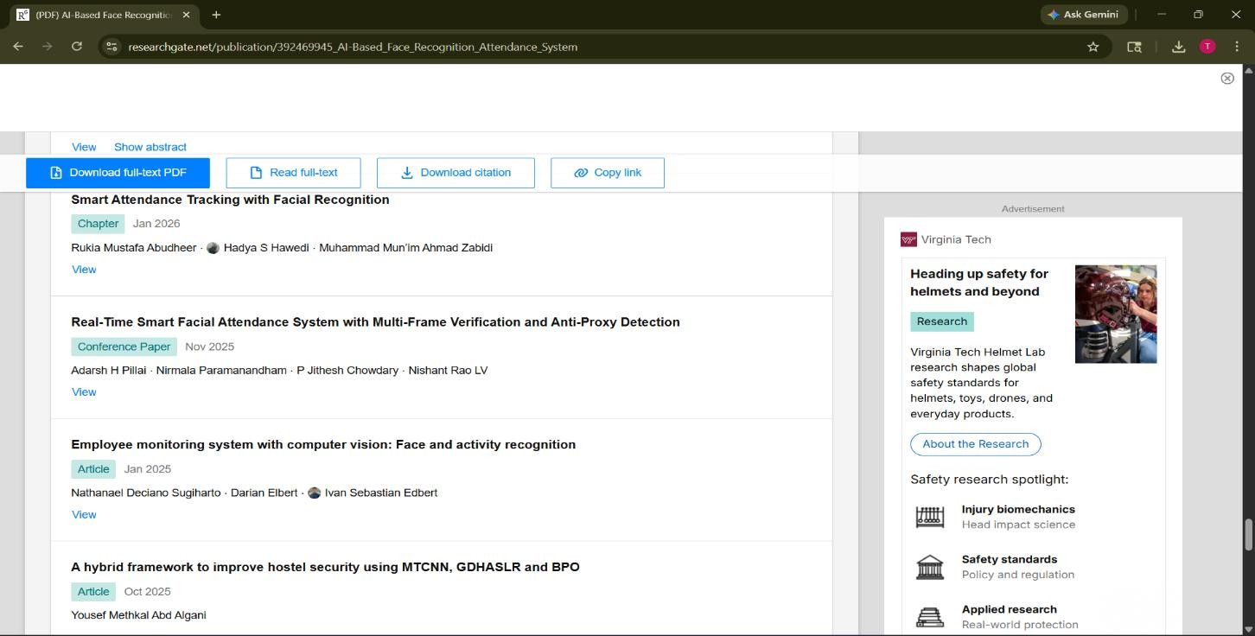
Figure A.2 Citation of the referred research paper

Presidency School of Computer Science and Engineering, Presidency University

[2] Smitha, P. S. Hegde, and Afshin,“Face Recognition Based Attendance Management
System,” International Journal of Engineering Research & Technology (IJERT), vol. 9, no. 5,
May 2020.
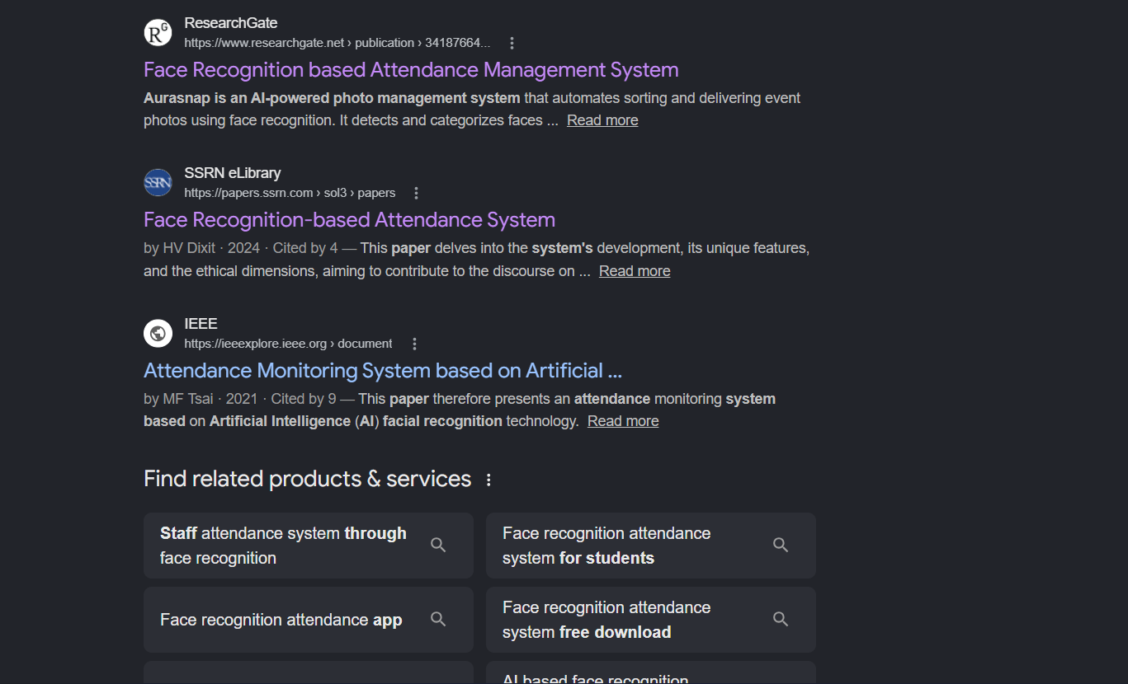
Figure A.3 Title of the publication of referred research paper

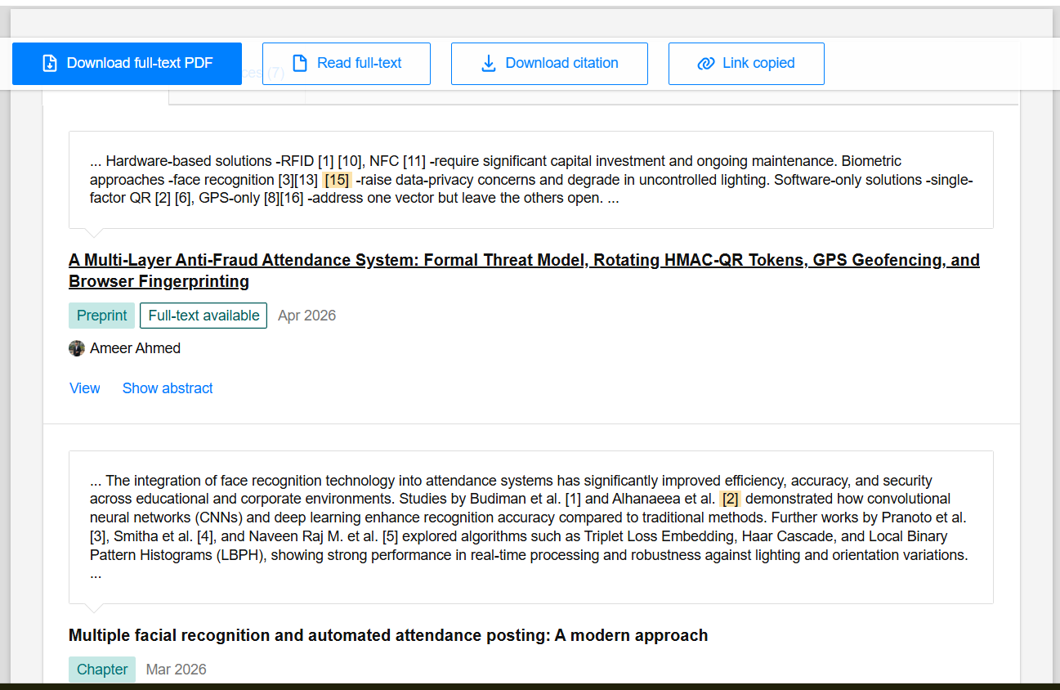
Figure A.4 Citation of the referred research paper

Presidency School of Computer Science and Engineering, Presidency University

[3] Sinan, M., Muneer, A., Khanum, M., Taskeen, S., & Venkatesh, T.,“AI-Based Smart
Attendance System Using Face Recognition,” Iconic Research and Engineering Journals, vol.
9, no. 6, 2025.
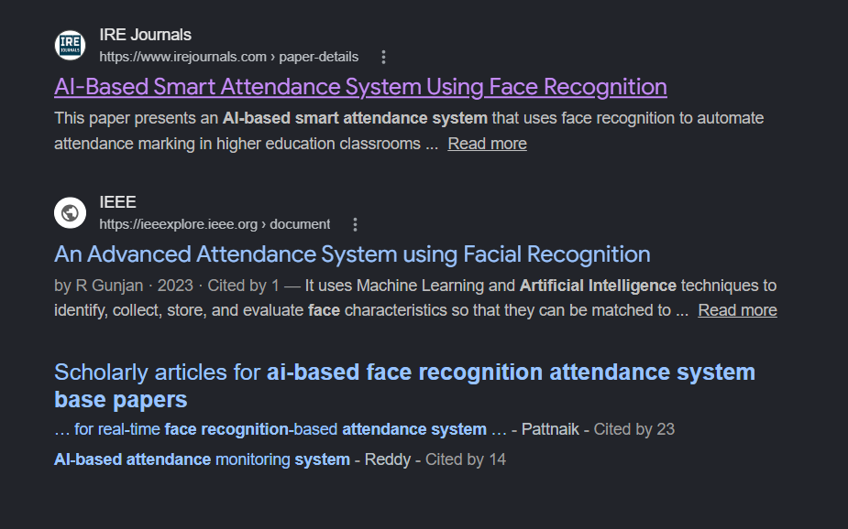
Figure A.5 Title of the publication of referred research paper


Figure A.6 Citation of the referred research paper

Presidency School of Computer Science and Engineering, Presidency University

APPENDIX

SCREENSHOTS

GitHub Link https://github.com/tejaswinireddy3232-blip/Internship

Source Code
  - Complete code for the Internship project is stored in GitHub for version control and collaboration purposes, with OpenCV implementation for real-time face detection and image processing.
  - Incorporates sophisticated facial recognition algorithms via InsightFace for accurate identification and efficient attendance tracking.

Screenshots
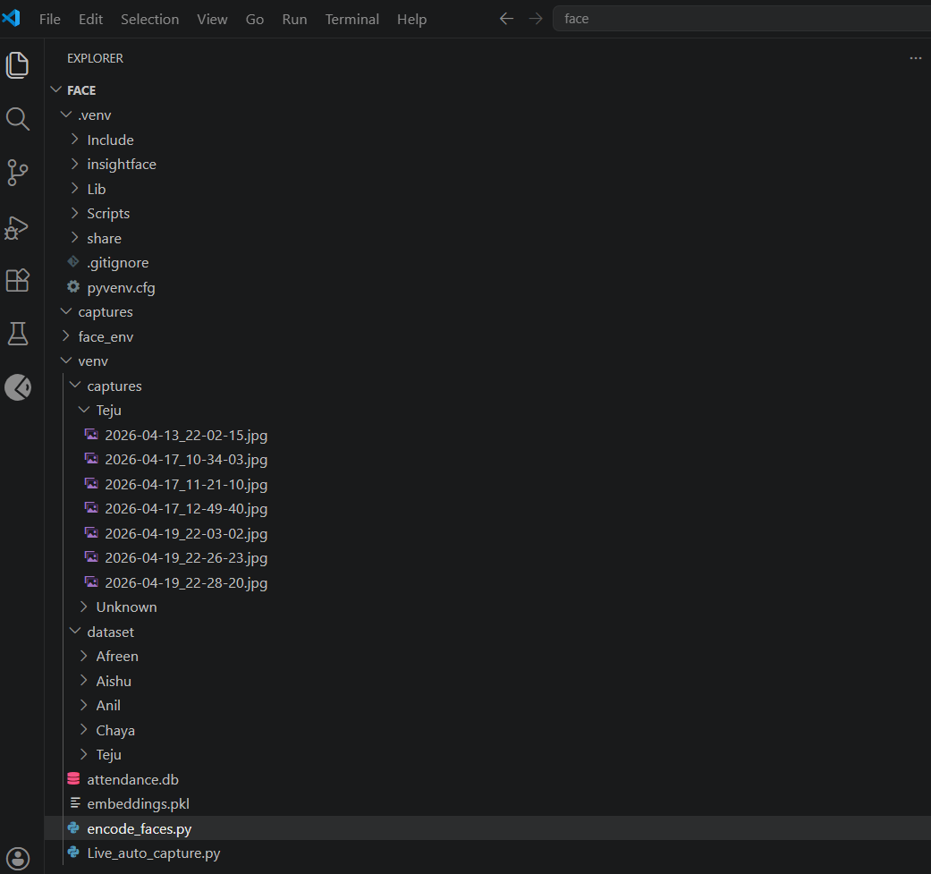

Figure B.1 Datasets and Captures

Presidency School of Computer Science and Engineering, Presidency University

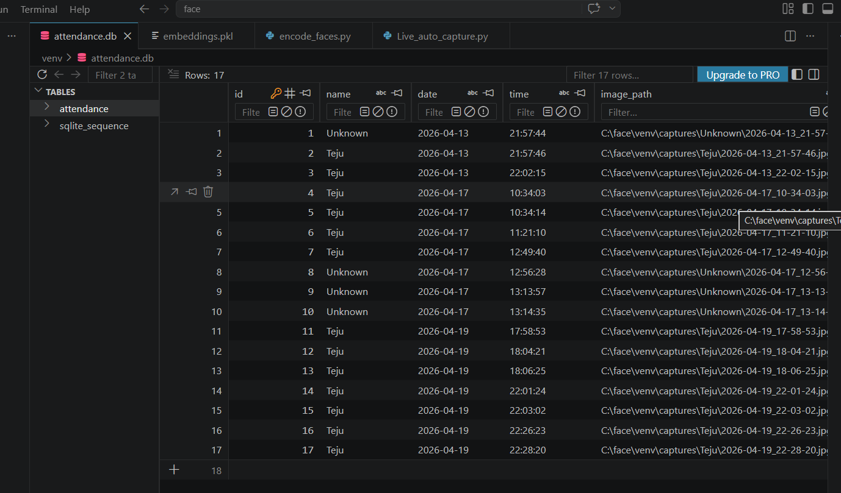

Fig B.2 SQLite Database.

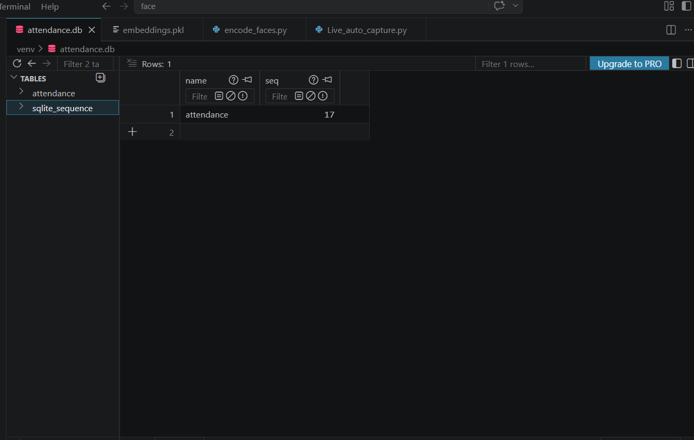
Fig B.3 SQLite Database Viewer

Presidency School of Computer Science and Engineering, Presidency University

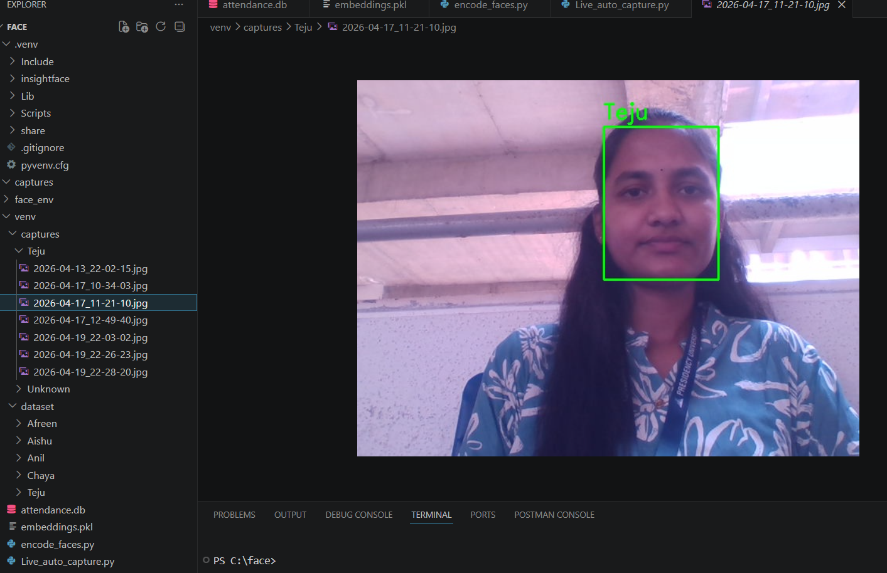
Fig B.4 Output.

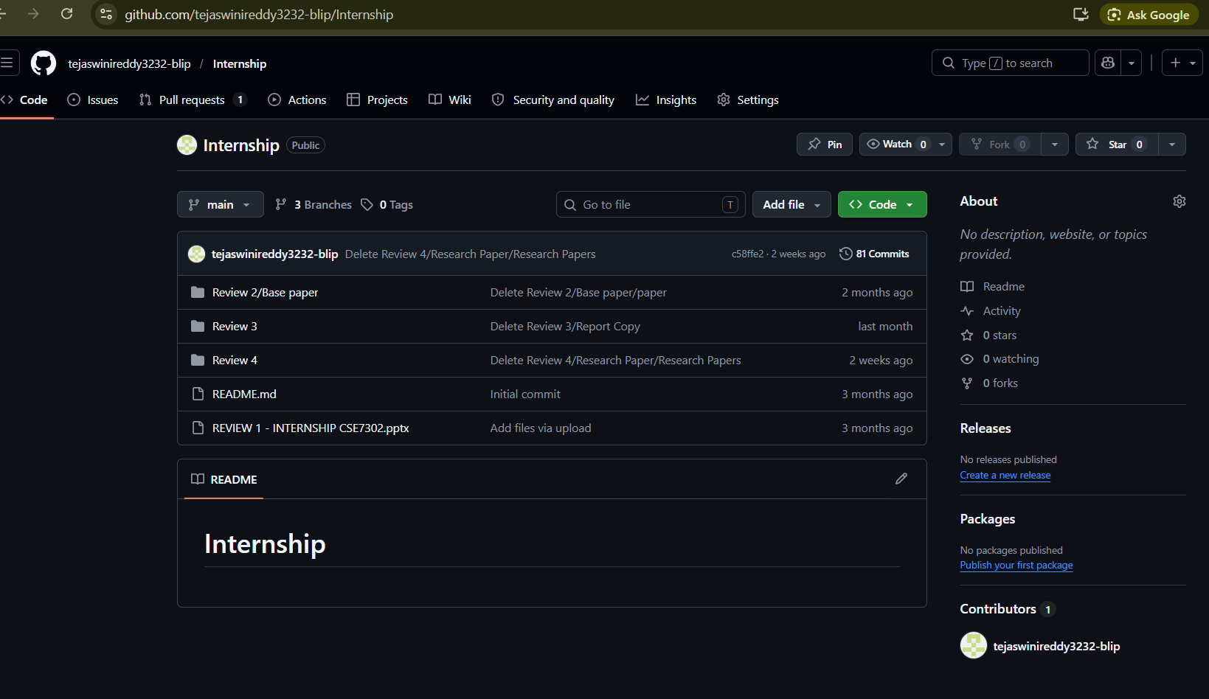
Fig B.5 Github Repository

Presidency School of Computer Science and Engineering, Presidency University

